 | Weekly Team Task Report | #13

Team: GeoLearn |  |  |  |  |  | Date: 4/21/2020
Project Title: Improving elementary education with custom online enironmental science lectures

 | Samuel Prassse  Present  On-time |  | Kaitlyn Grubb  Present  On-time |  | Tyler Pehringer  Present  On-time |  |  | Joshus Tenakhongva  Present  On-time

Recent Meetings:
- General Team Meeting
- Sponsor Meeting

TASKS COMPLETED since last meeting:

Task Title: Get website up and running | Task Initiation: 3/23 | Orig. Due Date: 4/10 | Status: In Progress
Who (%): Samuel (100%)
Description: Samuel is working on getting the Django app up and running on an Apache server on Elastic Beanstalk. All issues have been resolved and the website is up.
Expected Outcome: A fully functioning website prototype in beta build.

Task Title: Poster Due by COB | Who (%): Team (100%) | Rough Due Date: 4/19
Description: There is one more important change. As you know, every team has to prepare a poster and present that poster at Capstone. In the “virtual UGRADs” concept the organizers have come up with, UGRADs runs (virtually) for a *week* from 4/20-4/24…and they had wanted all posters and presentations by the 19th. We Capstone faculty pushed back saying you can’t deprive Capstone teams of a week, and got the 3/23 deadline through. But your POSTERS will be due by end of business on the 19th, so they can be part of the show and be viewed/judged in the poster competition. You will therefore want to be drafting your poster in the next few weeks as well, and reviewing it with your mentor. This is not a huge change from normal…just rules out last minute jobs on the poster.

Task Title: Develop complete website | Who (%): Tyler (100%) | Rough Due Date: 4/19
Description: Create a website on the CEFNS server to professionally document our project.

This week’s Tasks: Work plan for coming week
Task Title: Acceptance Demo | Who (%): Team (100%) | Rough Due Date: 5/1
Description: Work with your mentor develop a “Final
Demonstration Plan”, which is clearly driven by the functional and performance requirements that were developed for this project. This jointly-developed “demonstration plan” then becomes the agenda for an in-person demo with your project mentor, where you walk through and demonstrate all of the functionality promised

Task Title: Peer Eval #4 | Who (%): Team (100%) | Rough Due Date: 4/24
Description: Review and send off an Excel sheet containing the scores and description of our team ratings over the past few weeks. Due at capstone presentaiton time.

Task Title: Capstone Final Presentations | Who (%): Team (100%) | Rough Due Date: 4/23
Description: Capstone final presentations are due by end of business on Thursday April 23, the night before the regularly scheduled Capstone. The UGRADs folks promise there will be a way to upload them to the UGRAD site, which will be required. We will also upload them with BBlearn, for easy collection and access by team mentors for grading.

Upcoming Tasks: Planning
Task Title: Peer Eval #5 | Who (%): Team (100%) | Rough Due Date: 5/1
Description: Review and send off an Excel sheet containing the scores and description of our team ratings over the past few weeks. Due at end of semester.

Task Title: Final “As-Built” | Who (%): Team (100%) | Rough Due Date: 5/1
Description: The final report summarizes "the story" of the project into a single coherent narrative. If someone had time to read just one document to understand everything about this project, starting from
motivations and vision, summarizing the development process, and describing the resulting product,
this would be the document to read. Much of the material to be included in the report can and
should be shamelessly re-used from previous document products you've produced...with appropriate
condensing, seaming together and cleaning up, of course.

Task Title: Team reflection document | Who (%): Team (100%) | Rough Due Date: 5/1
Description: At the end of a project, it’s useful to go back and reflect on how the project went, how the team functioned, how effectively you used tools, and so on. This worksheet is designed to guide you in this process, and capture the outcomes.

Task Title: Final Project Delivery | Who (%): Team (100%) | Rough Due Date: 5/1
Description: The aim of formal product delivery is to make sure that the team has done its due diligence in
installing the product to the client’s satisfaction, and educating the client on how to operate the
product. It consists of two parts: The product User Manual, and the Product Delivery Checkoff Sheet.

Other Problems / Other Issues:

Schedule:
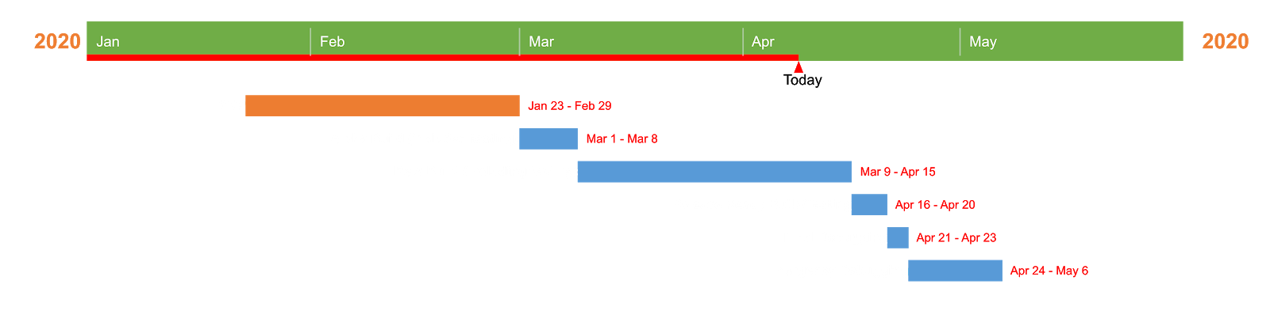

Github:
